Dear sir or madam,

Application for the (Internship)

Hello I’m Amerul Amin from Politeknik Port Dickson. Currently im pursuing Diploma Marketing in last semester. Im looking for internship in your company, lauk, as a marketing intern.

I am interested in applying for the Marketing (Internship) position that have advertised on your
internet. I would like to be considered for that position.

I recently working at Gloria Jeans Coffees as a assistant manager and also as a barista and with my experience, its provided me with a knowledge of how to communicate with people at all level. Besides that, i also good at giving suggestion and problem solving.

In addition, I expect to graduate from Port Dickson Polytechnic in December 2019 with a Diploma in Marketing. Based on my education and experiences, I am confident that I can hold for the post as Marketing Executive.

I would like very much to be a part of your team. If I am offered for this position, I will be ready to hit the ground running and help your company exceed its own expectations for success. I welcome the opportunity to discuss my qualifications for the position. I can be contacted through my email amerulcheaziz@gmail.com or give me a call at 011-10019793

Yours Faithfully,

Amerul Amin Bin Che Aziz

AMERUL AMIN BIN CHE AZIZ
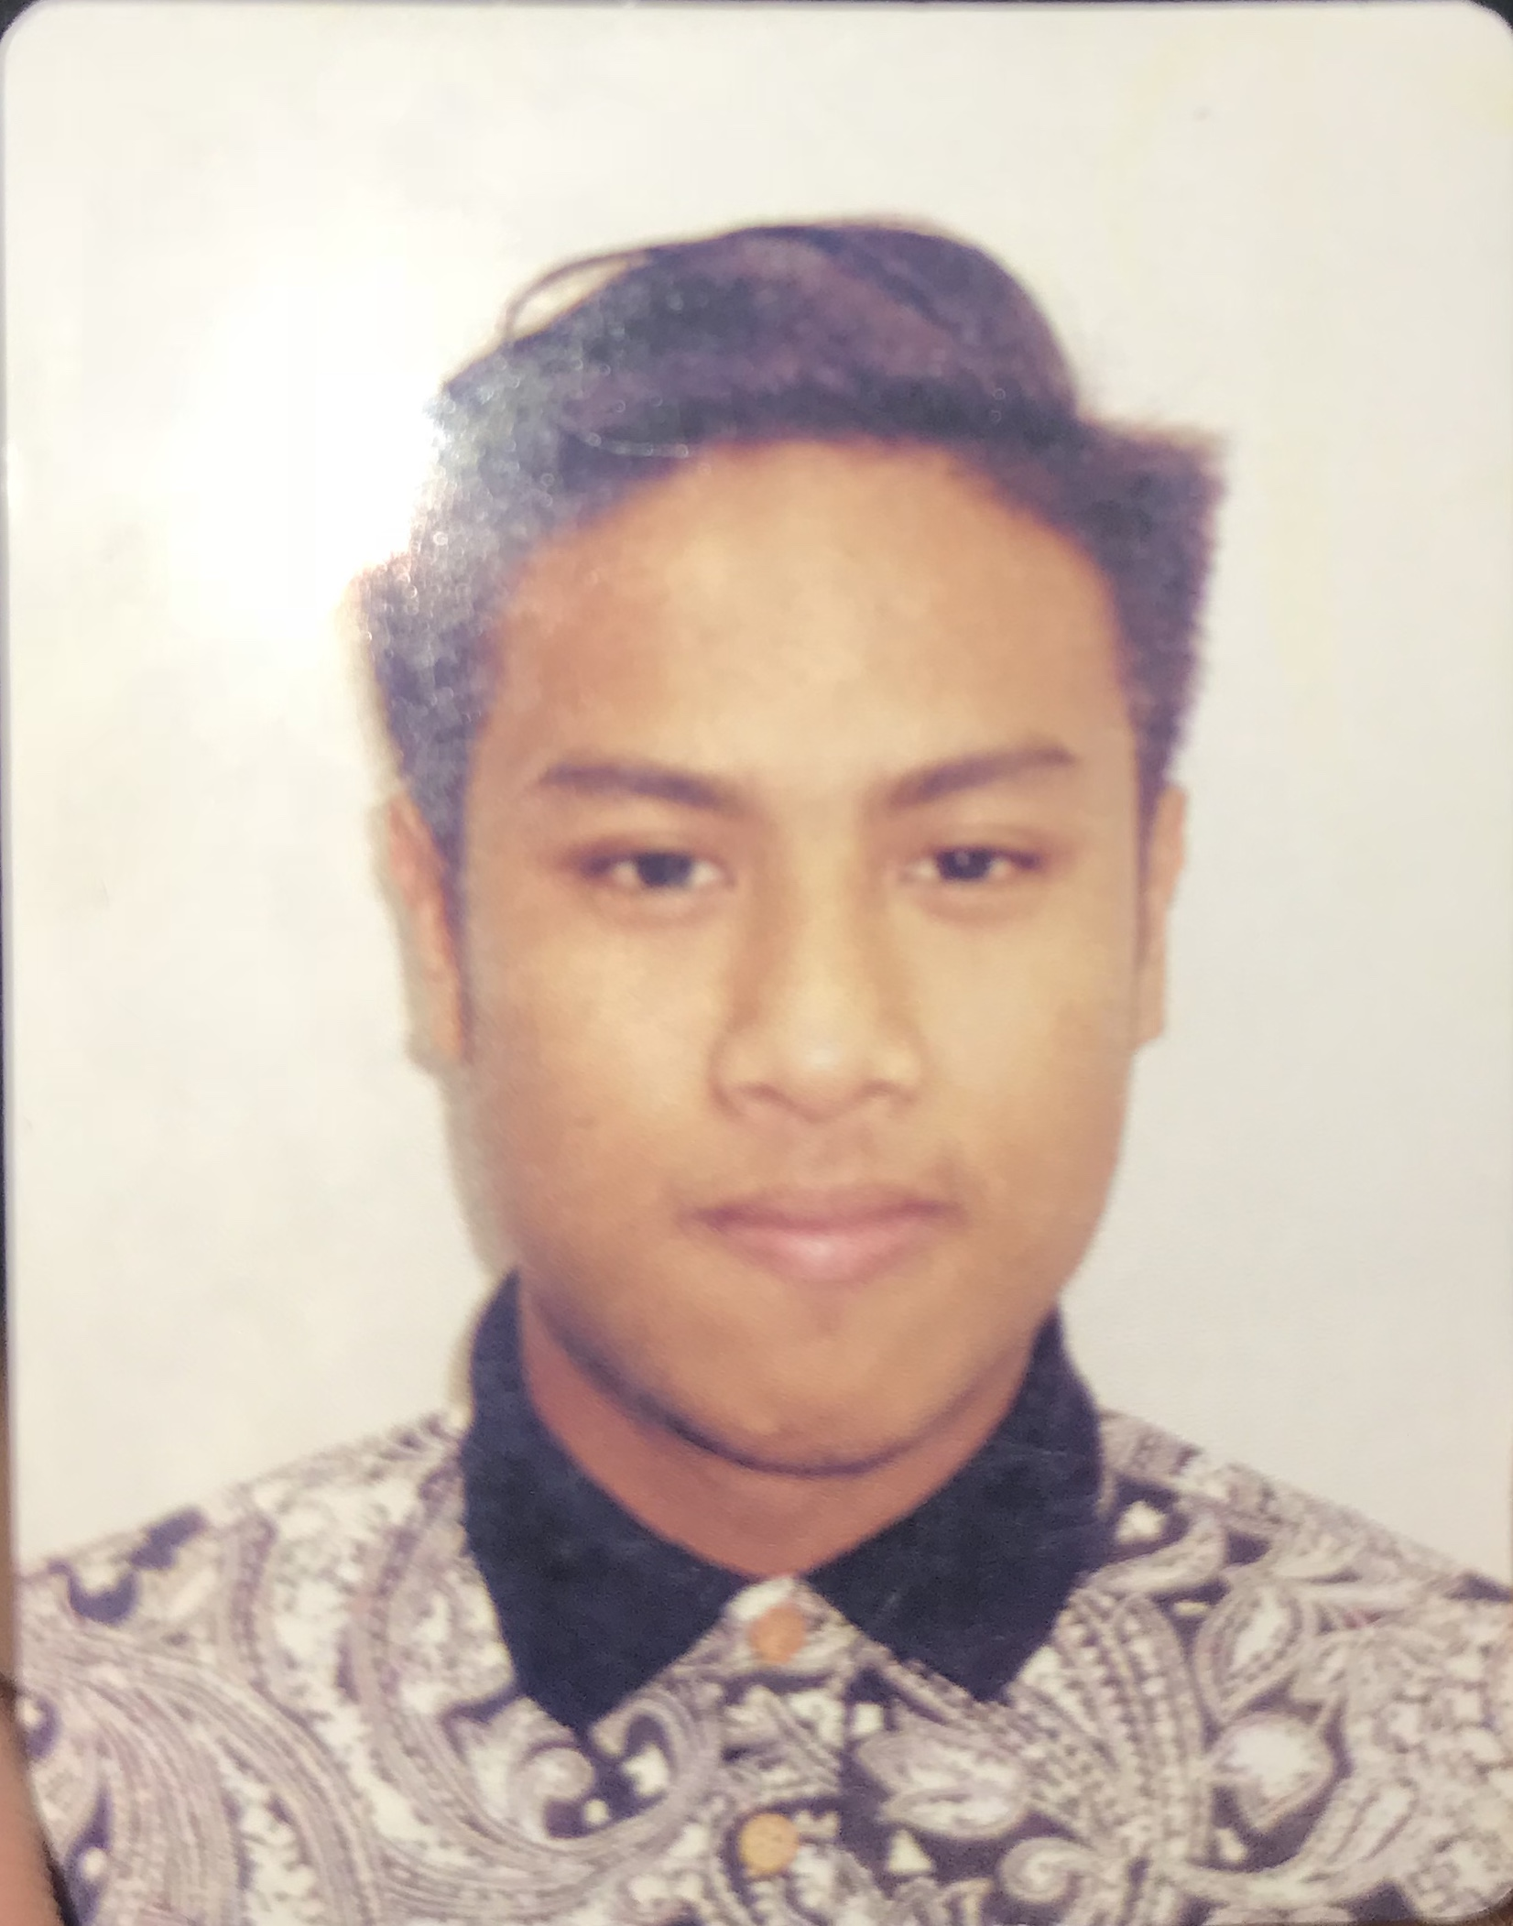
No. 3 Jalan PJS 7/15H,
Bandar Sunway,
46150 Petaling Jaya,
Selangor.

Tel: 011-10019793

PERSONAL DETAILS

IC No : 980818-56-5021
Age : 21
Race / Religion : Malay / Muslim
Date of birth : 18 August 1998
Nationally : Malaysian
Gender : Male
Status : Single
Healthy Status : Excellent
Height / Weight : 173/80
E-mail : amerulcheaziz@gmail.com

ACADEMIC QUALIFICATION

December 2016 – June 2019
Diploma In Marketing

2015
Sijil Pelajaran Malaysia (SPM)
SMK SULTAN ABDUL SAMAD PETALING JAYA

2013
Penilaian Menengah Rendah (PMR)
SMK SULTAN ABDUL SAMAD PETALING JAYA

SKILLS

Language : Malay (Excellent) / English (Good)

Computer : Microsoft Office (Words, Excel, Power Point, Access)

PERSONAL CHARACTERISTICS

Hardworking
Strong Interpersonal Skills
Positive personality
Able to work as a team
Ready to learn something new
Able to work under pressure, supervise

WORKING EXPERIENCES

DEC 2016
Barista (Gloria Jeans Coffees)
-Served Coffee, cleared tables.
-Preared storage report weekly
-Trained new staff on SOP system,guest services, cafe policies and procedure.

REFERENCES

- Name
EN AHMAD ZAILANI BIN AHMAD

Position
HEAD OF UNIT PERHUBUNGAN & LATIHAN INDUSTRI

Address
Politeknik Port Dickson,
KM.14, JALAN PANTAI,
SI RUSA,
71050 PORT DICKSON,
NEGERI SEMBILAN.

Contact number
06-662 8817
013-304 4017

- Name
PN DAMAISARI BINTI MOHD NAWI

Position
Politeknik Port Dickson Lecturer

Address
Politeknik Port Dickson,
KM.14, JALAN PANTAI,
SI RUSA,
71050 PORT DICKSON,
NEGERI SEMBILAN.

Contact number
06-66220000
010-3342514

AMERUL AMIN BIN CHE AZIZ
No. 3 Jalan PJS 7/15H,
Bandar Sunway,
46150 Petaling Jaya,
Selangor
Tarikh: 20/04/2019

PERMOHONAN PENEMPATAN LATIHAN INDUSTRI (LI)
Pelajar Politeknik Port Dickson Sesi JUN 2019 (1 Julai 2019 – 15 Nov 2019)

Merujuk kepada perkara di atas, sukacita dimaklumkan bahawa saya ;

Nama | : | AMERUL AMIN BIN CHE AZIZ
No K/P | : | 980818-56-5021
No Pendaftaran | : | 06DPR16F2012
Program | : | Diploma PEMASARAN

adalah seorang pelajar Politeknik Port Dickson.

- Saya dikehendaki menjalani latihan industri selama tempoh di atas sebagai salah satu syarat wajib bagi penganugerahan Diploma Politeknik Kementerian Pendidikan Malaysia. Untuk makluman tuan, semua pelajar PPD dilindungi insuran berkelompok (Takaful) sepanjang tempoh latihan industri.

- Sehubungan itu, sukacita sekiranya pihak tuan dapat mempertimbangkan permohonan saya dan memberi peluang kepada saya untuk menjalani latihan industri di firma tuan. Pihak tuan boleh meneliti resume / CV yang disertakan bersama surat ini bagi tujuan rujukan.

- Sekiranya pihak tuan bersetuju menerima saya menjalani latihan Industri ditempat tuan,sila isikan Borang Jawapan yang dilampirkan dan mohon faks ke 06-6622027 (POLITEKNIK PORT DICKSON)/e-mail; unitlipolipd@gmail.com pada kadar SEGERA. Sebarang pertanyaan boleh dikemukakan ke Unit Perhubungan Dan Latihan Industri Politeknik Port Dickson di talian 06-6622020/6628817. Surat penempatan rasmi akan dihantar oleh pihak POLITEKNIK sebelum saya melaporkan diri di firma tuan bagi tujuan pengesahan.

Kerjasama dan pertimbangan tuan amat dihargai.

Sekian, terima kasih.

Yang benar,
......................................................
(AMERUL AMIN BIN CHE AZIZ)

