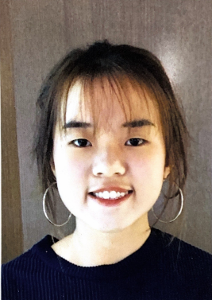
Leong Shu Min
28, Jalan Dayang 25/8
Bandar Mahkota Cheras
43200 Cheras, Selangor
011-10687828
leong_shumin@hotmail.com

Education |  | Universiti Putra Malaysia / Faculty of Food Science and Technology / Bachelor Science (Food Service Management) / CGPA 3.675  September 2018 – Present,Seri Kembangan  Victoria Institution / Sijil Tinggi Persekolahan Malaysia (STPM) / CGPA 3.17  June 2016 – December 2017,Kuala Lumpur  SMK Seri Bintang Selatan / Sijil Pelajaran Malaysia (SPM) / 3A+ 4A 3A-  January 2011 – December 2015,Kuala Lumpur
Experiences |  | Admin / DF Realty  April 2018 – August 2018 & July 2020 – September 2020  - Manages the database and ensure no conflicts occur.  - Successfully planned and coordinated company events and teamwork activities.  - Prepared, proofread and formatted the correspondence.  - Processed customer and account source documents by reviewing data for deficiencies.  Retail Associate / Uniqlo  December 2017 – March 2017 & June 2019 – July 2019  - Worked passionately in customer service in a high volume store.  - Achieved top 3 highest sales store in Malaysia.  - Processed shipment and ensure all merchandise are represented on the floor in full size run.  - Maintained a high tip average thanks to consistent customer satisfaction.  - Achieved sales target consecutively during working period.  Cashier / TCE Baby Expo  March 2016  - Ensure accurate amount was received from the customer.  - Reconciliation was done at the end of the day and there is no any variances.
Achievements |  | Tertiary Education  - President of Victoria Institution Girl’s Club  - Committee of Victoria Institution Science & Mathematics Club  - Volunteered in Community Project UPM  - Secretary of UPM Zhong Hua and Drama Sketch Class  - Completed 200 Hours Food Service Training Service in UPM  - Worked directly with Director of Human Resource of Pulse Grande Hotel (formerly known as Putrajaya Shangri-La Hotel) to increase knowledge in Human Resource  - Developed training plan for employees in Pulse Grande Hotel  - Committee for UPM Choir Competition  - Awardees for The Duke of Edinburgh’s International Award (Silver)  - Developed a website for Piccolo Café, Taman Equine  - Completed The Fundamentals of Digital Marketing certificate exam on Google Digital Garage  High School Education  - Participant in 1 Malaysia Community Service Mural Project  - Volunteered in Shah Alam National Botanical Park  - Committee member of Chinese Society and Science & Mathematics Club  - Committee in Chinese Society’s Annual Camp
Key skills & Abilities |  | Skills  ● ● ● ● ●  ● ● ● ● ●  ● ● ● ● ●  ● ● ● ● ●  ● ● ● ● ●  ● ● ● ● ●  ● ● ● ● ●  Presentation & Public Speaking  Active Listening  Written & Oral Communication  Creativity & Problem Solving  Languages  English  Malay  Mandarin  ● ● ● ● ●  ● ● ● ● ●  Cantonese  Spanish

